Project Development Phase
Model Performance Test
Date | 10 February 2025
Team ID | SWTID-2026-4440
Project Name | Auto Ticket Classification using Flow Designer
Maximum Marks | 10 Marks
Model Performance Testing:
Project team shall fill the following information in model performance testing template.
S.No. | Parameter | Values | Screenshot
1. | Metrics | Regression Model: MAE -, MSE -, RMSE -, R2 score -;  Classification Model: Confusion Matrix -, Accuracy Score - & Classification Report - | 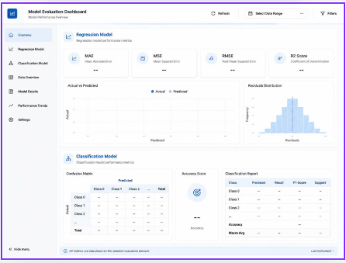
2. | Tune the Model | Hyperparameter Tuning -;  Validation Method - | 